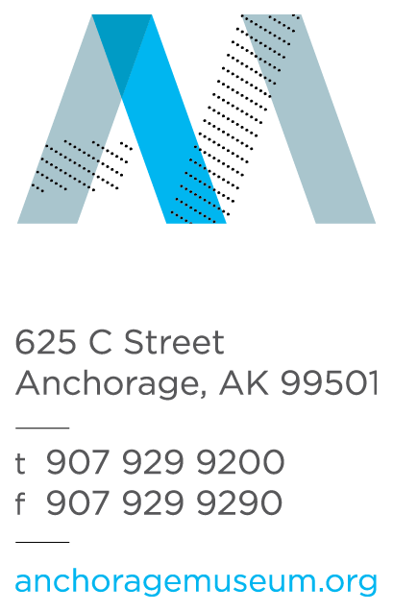
Anchorage Museum Summer Camp

Health History Form

Section I: Camper Information

Camper Name: Click to enter camper’s name (first & last)
Home Address: Click to enter home address
Gender: ☐ Male ☐ Female Birth Date: Click to enter date
Age Today: Select age Document completed on: Click to enter date

Section II: Parent/Guardian Information

Account Email: Click to enter primary email

Parent/Guardian Name: Click to enter name (first & last)
Phone (Daytime, Home, Alternate): Click to enter phone numbers

Secondary Parent/Guardian Name: Click to enter name (first & last)
Phone (Daytime, Home, Alternate): Click to enter phone numbers

Emergency Contact(s) (In the event that the parent/guardian(s) cannot be reached:
Please enter full name and daytime phone number for each contact

Emergency Contact 1: Click to enter full name and daytime phone
Emergency Contact 2: Click to enter full name and daytime phone
Emergency Contact 3: Click to enter full name and daytime phone

Other persons authorized to take the camper from the facility (in addition to emergency contacts): Click to enter names

Section III: Healthcare Providers & Insurance Information
Primary Physician: Click to enter full name and phone number
Preferred Hospital: Click to enter name

Medical Insurance Provider: Click to enter name
Group/Policy Number: Click to enter name or number
Section IV: Medications & Health History

List all routine (or “as needed”) medication that you authorize our staff to administer to your child during camp. Please send enough medication to last the entire time at camp.
Click to list medications

☐ I authorize the administration of the above medications, which I will provide to the Anchorage Museum on the first day of camp.

Does the camper have known allergies? ☐ No ☐ Yes
Description of allergies and reaction seen: Click to enter allergy details

List any dietary restrictions the camper has (not a true allergy, but would be a preference or requirement: Click to enter dietary restrictions

Topical Products: Do you give permission for the Anchorage Museum to distribute sunscreen, insect repellent, hydrogen peroxide, first aid ointments, calamine lotion, baking soda, lip balm (never shared), skin creams, band aids, and hand sanitizer to your camper as needed?
☐ Yes ☐ No

Do you have any additional information, or will you provide alternatives to the above items: Click to provide additional information and/or identify alternatives

Immunization History: Provide the dates of the most recent immunization below
☐ Current on all immunizations
Tetanus (10 year booster): Click to enter date
☐ Medical or religious exemption (to be provided by parent/guardian on the first day of camp)

Health History:
Of the following, the camper has had, or has been: (Check all that apply)

☐ Wearing glasses, contacts, or protective eyewear
☐ Hospitalized
☐ Recurrent/chronic illness
☐ Recent infection disease
☐ Recent injury
☐ Headaches
☐ Fainting or dizziness
☐ Passed out/had chest pain during exercise
☐ Skin problems
☐ ADD
☐ Current on all immunizations
☐ Asthma/wheezing/shortness of breath
☐ Diabetes
☐ Seizures
☐ Autism
☐ Asperger’s
☐ Emotional or behavioral difficulties

Explain any conditions below. If you treat with a medication, be sure to list that medication in the medications section and bring medication on the first day of camp.
Click to explain any conditions

Section V: Restrictions and Additional Information
Restrictions: I have reviewed the program and activities and feel my child can participate
☐ Without restrictions
☐ With adaptations Click to identify/explain adaptations

Additional Information: Please provide any additional information that you think is important or that my affect the camper’s ability to fully participate in the camp program:
Click to include additional information

Section VI: Release of Liability
I have requested the Anchorage Museum Association to allow my child to participate in camp activities. As a condition of receiving this benefit, I, the undersigned, do hereby agree to the following:

I understand that participation in camp activities can expose my child to dangers both from known and unanticipated risks. Acknowledging that such risks exist, I hereby release and discharge Anchorage Museum Association, its officers, agents, and employees from any and all claims or liability for personal injury or property damage my child may suffer while participating in the activity; including, but not limited to, any claim arising out of any condition of the premises at which the activity is held or the conduct of any person in connection with the preparation for, supervision of, or conduct of any activity, whether planned or unplanned. I specifically agree to release and hereby release Anchorage Museum Association and the officers, agents, and employees of the camp for any negligence of the camp, or its officers, agents or employees.

Consent to Treat:
I hereby give permission to the camp to provide routine health care, administer prescribed medications, and seek emergency medical treatment including ordering X-rays or routine medical tests. I agree to the release of any records necessary for insurance purposes. I give permission to the camp to arrange necessary related transportation for my child. This completed form may be photocopied for trips out of camp.

Further, the undersigned, individually and as parent(s) or guardians(s) of the participant(s) hereby authorize the Anchorage Museum Association to carry out any measures deemed necessary should an emergency occur, including securing, at the expense of the undersigned, appropriate medical treatment for the participant(s), and hereby release the Anchorage Museum Association, its agents, employees, and board members from any and all liability of claims arising out of the participant’s engagement in the above described event(s).

I verify I am a legal parent/guardian, that I have authority to make these decisions on behalf of my child, and I certify that the emergency contact, insurance, physician, and health history information, including immunization record, for my child was completed accurately and fully to the best of my knowledge, during the registration process. I have received, read, and will abide by the contents of the Parent Handbook.

Photo Release:
I hereby authorize the Anchorage Museum Association to photograph or videotape my child and agree that the AMA may indefinitely use or permit other persons to use the negatives, prints, or videotape prepared for such purposes and in such manner as may be deemed necessary to promote camps and the Anchorage Museum.

I certify that I have read the above provisions of this form, I understand them, and I agree to be legally bound by them. This consent will remain valid until August 11, 2017.

_______________________________________ _______________
Signature - Parent or Legal Guardian Date

_______________________________________
Printed Name – Parent or Legal Guardian

